**PYTHON PROGRAMMING (INT108)**



### **Submitted To Dr. Vishu**

Lovely Professional University

Jalandhar, Punjab, India.

**SUBMITTED BY :-** AVINASH TANWAR

(12206065)

**SECTION :-** K22GH

**ROLL NO. :-** 61

QUESTION:

Your task is to find if it is possible to cut the cake in the below mentioned ways for a given value of N. Given an integer N and a cake which can be cut into pieces, each cut should be a straight line going from the center of the cake to its border. Also the angle between any two cuts must be a positive integer. Two pieces are equal if their appropriate angles are equal. The given cake can be cut in following three ways:

* Cut the cake into N equal pieces.
* Cut the cake into N pieces of any size
* Cut the cake into N pieces such that no two of them are equal.

**ANSWER :-**

The code of the question in python idle

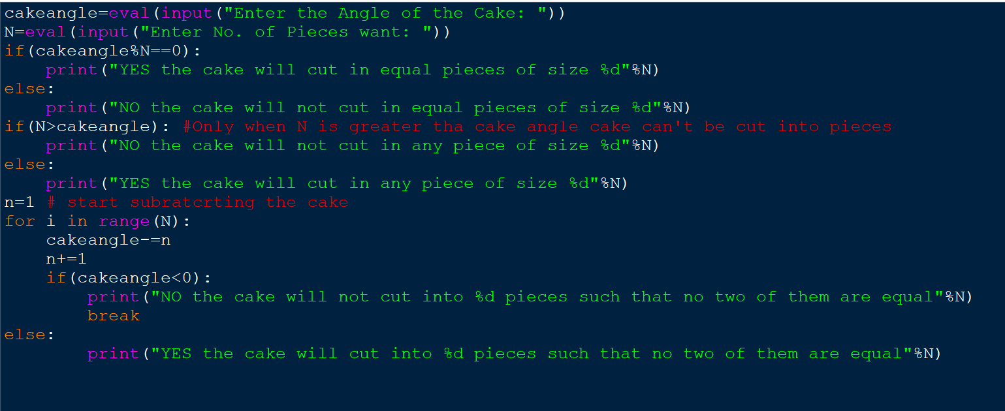

THE OUPUT WINDOW

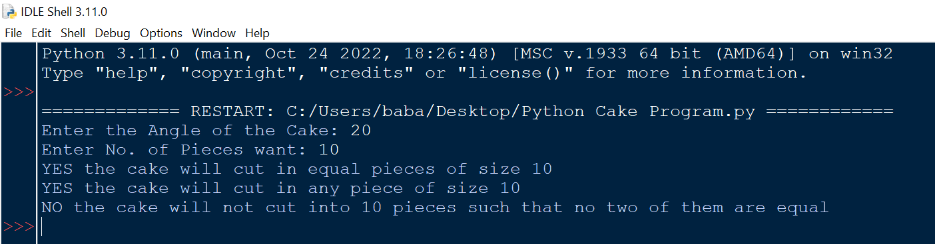

CODE:-

cakeangle=eval(input("Enter the Angle of the Cake: "))

N=eval(input("Enter No of Pieces: "))

if(cakeangle%N==0):

print("YES the cake will cut in equal pieces of size %d"%N)

else:

print("NO the cake will not cut in equal pieces of size %d"%N)

if(N>cakeangle): #Only when N is greater tha cake angle cake can't be cut into pieces

print("NO the cake will not cut in any piece of size %d"%N)

else:

print("YES the cake will cut in any piece of size %d"%N)

n=1 # start subratcrting the cake

for i in range(N):

cakeangle-=n

n+=1

if(cakeangle<0):

print("NO the cake will not cut into %d pieces such that no two of them are equal"%N)

break

else:

print("YES the cake will cut into %d pieces such that no two of them are equal"%N)